# Decoding Cleanroom Specifications: A Comprehensive Guide

## 1. Introduction

A cleanroom is a controlled environment maintained to filter out pollutants such as dust, airborne microbes, and aerosol particles and make the surroundings clean. In this process, the outside air goes through special filters called High-Efficiency Particulate Air (HEPA) or Ultra Low Particulate Air (ULPA) filters to make the air decontaminated and then enter the controlled environment. The room has positive pressure that causes a specific pattern of airflow to push out any dirt/ impurities that are present inside the room. The contaminated air is either returned to the ambient or sent back through the filters and the process repeats again in a loop. Companies that make things easily affected by air dirtiness really value cleanrooms because they keep the things they make safe and good quality.

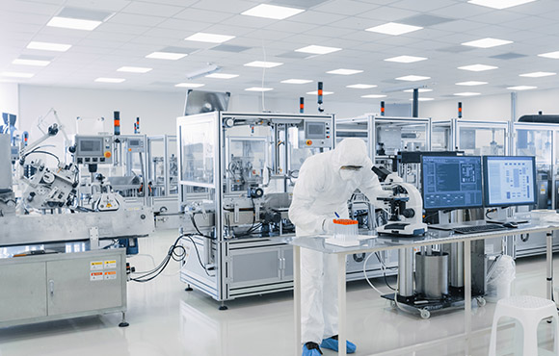

Figure: Cleanroom

**1.1Applications and Importance**

1. **Controlled Environment:** The main objective is to create low levels of particulates and contaminants essential for manufacturing, research, and technological processes.
2. **Environmental Variables:** Even variables like temperature, humidity, and airflow to create a suitable and desired environment can be controlled with cleanrooms.
3. **Precision Manufacturing:** In industries like nanotechnology, and semiconductor manufacturing, there is no space for minor contaminants, making classrooms crucial for precision-requiring industries.
4. **Cost Efficiency:** From an overall perspective, creating classrooms leads to long-term cost savings as it minimizes product defects, waste, and rework.
5. **Applications in various industries like:**

* Manufacturing Companies
* Research Facilities
* Compounding pharmacies
* Isolation room for hospitals
* Medical Laboratories
* Semiconductor and microelectronic
* Aerospace Industry
* Nanotechnology Production
* Optics and Lens Manufacturing
* Military Applications

**1.2 Construction of cleanroom**

* Cleanrooms should be built with airtight walls and ceilings with good internal finishing.
* Maintain the cleanrooms at a positive pressure.
* The inner surfaces should not break into particles in the surrounding environment.
* Floors should withstand strong solvents and acids they might get attacked from.
* 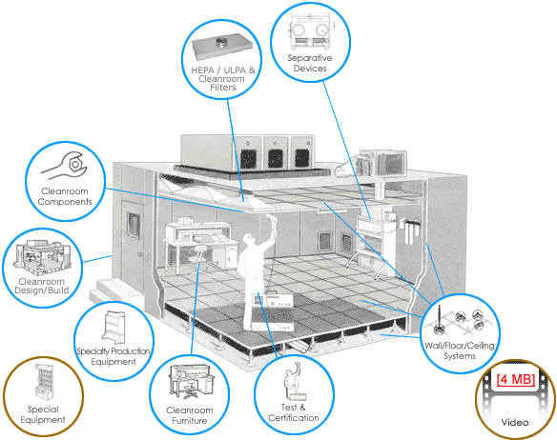All internal walls should comprise of rigid metal or plastic sheets, fixed to a conventional studded wall frame.

Source: <https://www.filtrationtechnology.com/crdesignbuild.shtml>

## 2. Understanding Cleanroom Specifications

Cleanrooms are classified according to the level of cleanliness (particle count of the air)and are checked at timely intervals to make certain they are able to maintain their classification.

1. Determine your cleanroom size and the number of areas that need to have their particles measured.
2. Determine what level of cleanliness you need for your desired classification.  
   Measure the required areas.
3. Take the averages of the number and size of particles in each location for the cleanroom.
4. Use a particle counter that will automatically find the Upper Confidence Limit to determine the type of classification you fall under.

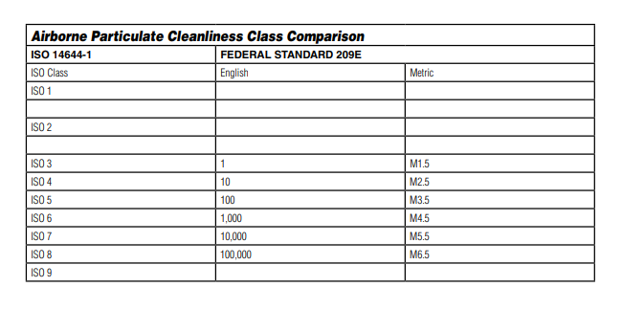

<https://www.terrauniversal.com/media/asset-library/i/s/iso_cleanroom_standards_and_federal_standard_209e.pdf>

 U.S. General Administration’s standards **(FS209E)** were used worldwide before the introduction of cleanroom classifications and standards by the International Standards Organization **(ISO)**.FS is forecasted to be completely replaced by ISO standards in the next 5 years. FS209E consists of six classes where Class 1 is considered as the cleanest and Class 100,000 as the dirtiest.

ISO classification system adds two cleaner standards and one dirtier standard with the cleanest cleanroom as class 1 and the dirtiest as class 9. ISO class 3 is nearly equal to FS209E class 1, while ISO class 8 nearly equals FS209E class 100,000.

|  |  |  |  |  |  |  |
| --- | --- | --- | --- | --- | --- | --- |
| Fed.Std | Max. Number of Particles/ m3 equal to or above | | | | | |
| 209E | 0.1µm | 0.2µm | 0.3µm | 0.5µm | 1µm | 5µm |
| M1 | 350 | 75.7 | 30.9 | 10 |  |  |
| M1.5 | 1,240 | 265 | 106 | 35.3 |  |  |
| M2 | 3,500 | 757 | 309 | 100 |  |  |
| M2.5 | 12,400 | 2,650 | 1,609 | 353 |  |  |
| M3 | 35,000 | 7,570 | 3,090 | 1,000 |  |  |
| M3.5 |  | 26,500 | 10,900 | 3,530 |  |  |
| M4 |  | 75,700 | 30,900 | 10,000 |  |  |
| M4.5 |  |  |  | 35,300 |  | 247 |
| M5 |  |  |  | 100,000 |  | 618 |
| M5.5 |  |  |  | 353,000 |  | 2,470 |
| M6 |  |  |  | 1,000,000 |  | 6,180 |
| M6.5 |  |  |  | 3,530,000 |  | 24,700 |
| M7 |  |  |  | 10,000,000 |  | 61,800 |

|  |  |  |  |  |  |  |
| --- | --- | --- | --- | --- | --- | --- |
| ISO Class | Max. Number of Particles/ m3 equal to or above | | | | | |
|  | 0.1µm | 0.2µm | 0.3µm | 0.5µm | 1µm | 5µm |
| ISO 1 | 10 | 2 |  |  |  |  |
| ISO 2 | 100 | 24 | 10 | 4 |  |  |
| ISO 3 | 1,000 | 237 | 102 | 35 | 8 |  |
| ISO 4 | 10,000 | 2,370 | 1,020 | 352 | 83 |  |
| ISO 5 | 100,000 | 23,700 | 10,200 | 3,520 | 832 | 29 |
| ISO 6 | 1,000,000 | 237,000 | 102,000 | 35,200 | 8,320 | 295 |
| ISO 7 |  |  |  | 352,000 | 83,200 | 2,930 |
| ISO 8 |  |  |  | 3,520,000 | 832,000 | 29,300 |
| ISO 9 |  |  |  | 35,200,000 | 8,320,000 | 293,000 |

Source: <https://astragroupuk.com/classification-of-cleanrooms/>

## 2.1 Key Elements of Cleanroom Specifications

Source: <https://www.airwoods.com/news/key-elements-of-cleanroom-design/>

**1. Airflow Rates and Direction:** Specific airflow rates and directions are maintained in the cleanroom to ensure a uniform distribution of filtered air and discard the formation of stagnant air pockets where particles could mount up. More air is needed for bigger rooms.

**2. Pressurization:** With the help of 2 common pressurization methods, cleanrooms are pressurized to create controlled air movement to prevent contamination of dirt/dust.

* Positive Pressure: By keeping the cleanroom at a higher pressure than its adjacent areas, the entering of unfiltered air from the outside air can be prevented.
* Negative Pressure: By keeping the cleanroom at a lower pressure than the surrounding area, escaping contaminants from the cleanroom to other parts of the facility can be prevented.

**3. Temperature and Humidity Control:** In order to prevent the introduction of moisture, and contaminants in the environment and protect sensitive equipment from damage due to unsuitable temperature and humidity levels, cleanrooms focus on control over temperature and humidity levels. This makes the working environment conducive to consistent manufacturing processes.

**4. Particulate Count:** As mentioned before, cleanrooms are classified based on ISO standards that depend on the maximum allowable particle count /m3. Particulate count sets benchmarks for the maximum level of contamination that can be present for the planned processes or industries. Also, the materials used in cleanrooms play a vital role in establishing cleanliness levels by minimizing the level of contaminants caused by internal generation.

## 3. Designing to Cleanroom Specifications

Selecting the materials and designs for constructing a cleanroom should optimize installation costs while also ensuring the long-term safety and quality standards of the cleanroom.

## 3.1 Material Selection for Cleanrooms

* **Flexibility:** If you have an expansion of the cleanroom in mind, modular cleanroom setups with moveable wall panels offer better adaptability.
* **Standards:** Different materials cater to different ISO cleanroom classifications.

|  |  |
| --- | --- |
| SoftWall | creates ISO Class 7-8 cleanrooms |
| RigidWall | creates ISO Class 5-6 cleanrooms |

* **Cleaning Agents:** HardWall cleanroom wall materials necessitate coatings that are powerful cleaning agents. However, RigidWall materials like acrylic, PVC, and polycarbonate are apt for less aggressive cleaning agents and processes.
* **Durability:** Aluminum structures are lightweight and they are mostly scratch-resistant. Lighter materials (vinyl modular panels, epoxy-coated drywall) can be easily scratched which generates particles that can interfere with processes.
* **Cost:** Obviously, the final decision is based on budget; it includes particulate control while investing in airflow, filtration systems, and energy efficiency. The finishing should be affordable with optimum features. Some commonly used materials in the cleanroom are:
* Aluminum, steel, and epoxy-coated stainless steel are used for modular wall and ceiling panels
* Epoxy-coated, resin flooring, vinyl composition tile (VCT) for flooring
* Tempered glass or polycarbonate for windows and glazing.
* Silicone or EPDM (ethylene propylene diene monomer) for gaskets
* Air diffusers, HEPA/ULPA filters, ductwork, and dampers are made from materials that prevent particle shedding.
* Stainless steel or impact-resistant plastics for wall and corner guards

## 3.2 Layout and design considerations

**1. Determine Project Budge:** Considering the size, type, classification standards, and design complexity, determine the budget beforehand to avoid unplanned expenses.

**2. Consider a Modular Cleanroom for Greater Design Flexibility:** Modular cleanrooms constructed from pre-fabricated components offer faster installation as well as versatility in the sense of future modifications, expansions, or reconfigurations.

**3. Choose the Right ISO Classification for Your Application:** With the help of information about the particle size and cost-benefit analysis, select the apt ISO classification and optimize the design.

**4. Understand Your Process Flow:** You need to define operational protocols to guide personnel as well as product movement by planning space allocation and designing optimal work surface layout to have efficient entry and exit.

**5. Budget-Aligned Material Selection:** You need to select materials on the basis of non-particle shedding characteristics, chemical compatibility, and ESD protection while considering the budget.

**6. Optimize HVAC System Design:**

* Do not place chairs, equipment, or furniture in areas that are conduit to vents.
* Use chairs that allow airflow through.
* Use shelves with perforations or bars
* Do not stack the equipment too closely together
* Use modular furniture as they are easy to move

## 3.3 HVAC (Heating, Ventilation, and Air Conditioning) system design for Cleanrooms

**1. Airflow Control:**

HVAC systems ensure proper airflow control throughout the cleanroom. Also, they maintain positive and negative pressures as required.

**2. Air Filtration:**

High-efficiency particulate air (HEPA) and ultra-low penetration air (ULPA) filters remove particles to meet the cleanliness requirements of the cleanroom.

**3. Temperature and Humidity Control:**

HVAC systems have heating, cooling components, humidifiers, and dehumidifiers.

**4. Backup Systems:**

HVAC systems constitutes of backup systems that can automatically activate in case of primary system malfunctions to ensure smooth process flow.

**5. Energy Efficiency:**

HVAC design should be energy-efficient by having variable speed drives, heat recovery systems, and optimized airflow designs that add to energy savings.

**6. Compliance with ISO standards:**

HVAC system designs need to be aligned with the ISO classification of the cleanroom.

**7. Monitoring and Control Systems:**

HVAC systems constitute of real-time monitoring and control of temperature, humidity, pressure differentials, and airflow rates.

## 4. Maintaining Cleanroom Specifications

**A. Regular Monitoring and Testing:**

* You can use particle counters, environmental sensors, and monitoring systems should be used for regular monitoring of particle counts, temperature, humidity, and pressure differentials.
* You need to perform routine air quality tests to ensure and maintain the cleanliness levels in compliance with the ISO classifications.

**B. Cleaning and Maintenance Procedures:**

1. You should use deionized water to scrub all surfaces, floors, walls, and benches.
2. [Multi-bucket mopping system](https://www.gotopac.com/catalogsearch/result/index/?manufacturer=1313&q=contec) with non-marring wheels, seamless buckets, and dirty water control can be used.
3. Floors should be damp mopped daily before normal work shifts with distilled water and vacuumed dry.
4. You should mop the floors weekly with detergent and a [HEPA filter vacuum](https://www.gotopac.com/liberty-20-2211.html).
5. Vacuum walls and ceilings should be used daily to remove deposits.
6. You should clean walls with a sponge and distilled water.
7. You have to move slowly in the clean room to prevent air turbulence.
8. All the tools should be cleaned before entering with a 70% IPA solution.
9. HEPA-filtered air should not be allowed to reach your body.
10. 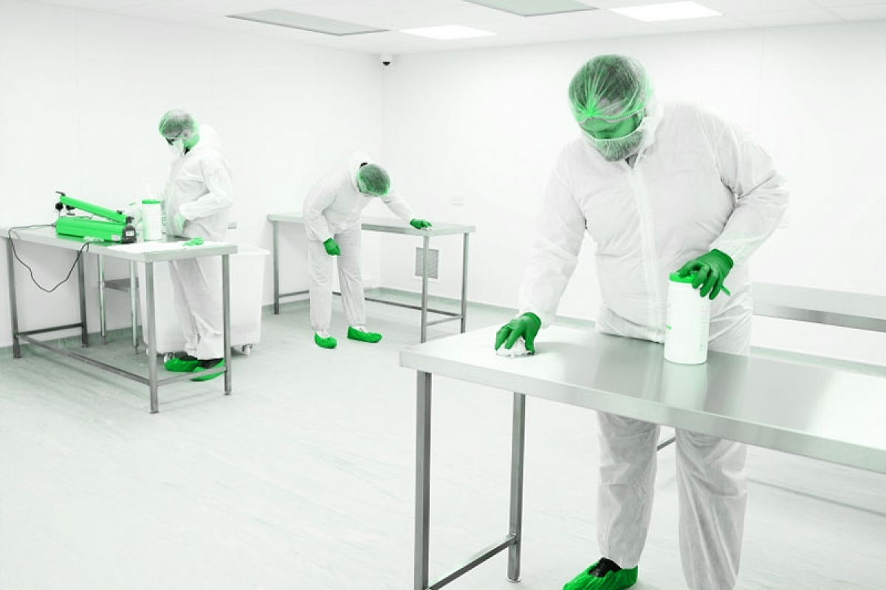During break time, all products, supplies, and materials should be covered.

Figure Maintenance of cleanrooms

Source:<https://www.cleanroom-industries.com/en/resources/item/400-cleaning-sterilization-cleanroom>

**C. Staff Training and Protocols:**

* The rules should be kept in mind while entering the classroom by the personnel for their safety and for the prevention of cleanroom contamination. Personnel should be aware of cleanroom protocols, gowning procedures, and steps to be followed within the controlled environment.
* Emphasize hand hygiene, and attire maintenance and restrict unnecessary movements that could generate particles leading to cleanroom contamination.
* The entry and exit protocols must be strictly followed so that no contaminants enter the cleanroom.
* All the staff need to be properly trained on emergency procedures to handle unexpected incidents while safeguarding the cleanliness of the cleanroom.

# 5. Case Studies

|  |  |  |
| --- | --- | --- |
| **S.N.** | **Type of classrooms** | **Application** |
| 1. | **Modular clean rooms** | * Microelectronics * Printing Rooms * Pharmaceutical Packaging * Gown Rooms * Laboratories * Medical Device Manufacturing & Packaging * Dry Rooms |
| 2. | **Softwall Cleanrooms & Curtain Dividers** | * Dust control * Specific ISO classifications * Flexible manufacturing enclosures * Laser rooms |
| 3. | **Coordinate Measuring Machine (CMM) rooms to control temperatures, humidity, ISO classifications, air velocity, and pressurization.** | * Machinery Manufacturing Inspection * Gauge Calibration * Medical Applications * Automotive Part Fabrication & Testing Applications * Energy Applications |
| 4. | **Machine Enclosures & Test Rooms control from noise, temperature, humidity and particulates.** | * Protecting sensitive equipment from harsh environments * Facilitating the movement of large equipment and materials * Housing large calibration or processing equipment * Production line retooling * Automation enclosures |

**6. Future Trends in Cleanroom Specifications**

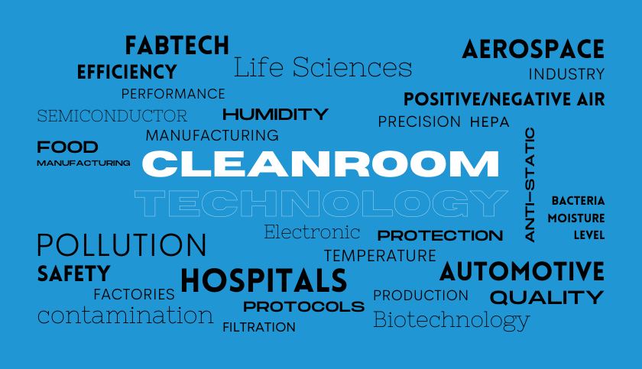

Source: <https://fabtechnologies.com/industries-benefit-from-the-cleanroom-technology/>

1. **Advanced Cleanrooms:** Real-time monitoring of critical parameters that include air quality, temperature, and humidity can be facilitated with the integration of Internet of Things (IoT) devices and sensors in cleanrooms. This data-driven approach can be utilized to increase efficiency and reduce energy consumption, and operation costs. Likewise, proactive maintenance can be enabled by providing early alerts for potential deviations.
2. **Improved Filtration and Airflow Control:** Particle contamination can be precisely controlled with advancements in filtration systems and airflow control mechanisms. It includes the development of novel HEPA and ULPA filter materials. HEPA filters are effective in capturing micro-size particles. And, ULPA filters assure a superior level of purity inside the dedicated area. Moreover, the development of airflow management systems that are adaptive to changing conditions can also be emphasized.
3. **Automation and robotics:** With the expansion in automation and usage of robotics, cleanroom operations have been constantly improved. Deployment of these technologies such as automated cleaning systems, material handling, and remote monitoring have reduced the number of human laborers. On the other hand, it has minimized the risk of contamination and the need for cleaning, and therefore has improved productivity.
4. **Utilization of 3D printing in cleanroom manufacturing:** Complex components with reduced contamination risks can be generated with the integrated implementation of 3D printing technology in cleanroom environments. 3D printed materials are adaptable to acids, bases, and different solutions and hence can be used in regular production in a cleanroom. The integrity of the final product can be ascertained by designing and manufacturing it in a controlled environment.

## 7. Conclusion

Cleanroom specifications are pivotal to developing things with precision and advanced technology. This guide has demonstrated that the cleanroom specifications not only provide a clean place but also the mere requirement of care and attention to the rules. Further, cleanroom specifications assist in developing things perfectly: from making medicine to electronics and even in space technology. Also, we came to learn that cleanrooms require specific rules for particulars like air and temperature. The guide also familiarizes us with the importance of selecting the right materials and maintaining everything clean. Several practical examples have demonstrated to us the application and procedure of cleanroom rules in different industries. Similarly, cleanrooms can be further enhanced with novel technology and eco-friendly ideas. To sum up, cleanroom rules play a significant role in making safe and high-quality things.